**Assignment Four**

**Problem Eight (abcd only) (2 Hours mostly because Visio)**

Table 4-4 shows a relation called GRADE REPORT for a university. Your assignment is as follows:

1. Draw a relational schema and diagram the functional dependencies in the relation.

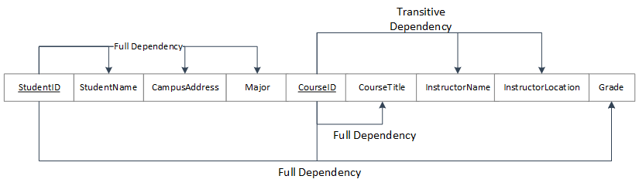

1. In what normal form is this relation?

Because this relation still contains transitive dependencies, but does not contain multivalued attributes or partial dependencies, it is in 2NF.

1. Decompose GRADE REPORT into a set of 3NF relations.

The only relation that needs to change is the transitive dependencies, and so one can have

**Student ID ->** StudentName, CampusAddress, Major

**CourseID ->** Course Title, *InstructorName*

**InstructorName ->** InstructorLocation

**StudentID, CourseID ->** Grade

1. Draw a relational schema for your 3NF relations and show the referential integrity constraints.

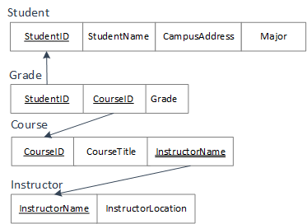

*Note:* The bold (or double) underline under instructor name signifies it as a foreign key.

**Problem Sixteen (1 hour)**

Figure 4-34 shows an EER diagram for Vacation Property Rentals. This organization rents preferred properties in several states. As shown in the figure, there are two basic types of properties: beach properties and the mountain properties.

1. Transform the EER diagram to a set of relations and develop a relational schema.

**RenterID ->** FirstName, MiddleName, LastName, Address, PhoneNum, Email, AgreementID

**AgreementID->** BeginDate, EndDate, RentalAmount

**PropertyID->** StreetAddress, CityState, ZIP, NbrRooms, BaseRate, PropertyType, AgreementID

**BPropertyID->** BlocksToBeach

**MPropertyID->** Activity

1. Diagram the functional dependencies and determine the normal form for each relation.

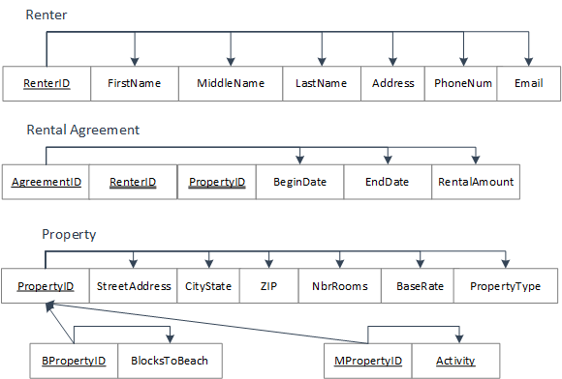

All of these relations appear to be in 3NF as there are no partial or transitive dependencies.

1. Convert all relations to third normal form, if necessary, and draw a revised relational schema.

The relations are in 3NF.

1. Suggest an integrity constraint that would ensure that no property is rented twice during the same time interval.

For a given AgreementID, no new ID may be made with an equal property ID that has begin date earlier than the end date of former agreementID.

**Problem Twenty (45 Minutes)**

Examine the set of relations in Figure 4.37. What normal form are these in? How do you know this? If they are in 3NF, convert the relations into an EER diagram. What assumptions did you have to make to answer these questions?

This relations are in 3NF. There are no transitive or partial dependencies in any of the relations.

The diagram is on the following page. In making the diagram, I assumed that the judge could only preside over a single court and that a lawyer could be certified by multiple bar associations. That would be the only reasoning in my mind to make a separate relation. I also assumed that relation was an associative entity between a client, a case, and an attorney.

